Multiple-choice section

|  |  |  |  |  |  |  |  |  |
| --- | --- | --- | --- | --- | --- | --- | --- | --- |
| Question | 1 | 2 | 3 | 4 | 5 | 6 | 7 | 8 |
| Answer | B | C | A | B | C | C | A | D |

Question 1 [8.1]

B

Between 180° and 360° is a reflex angle.

Question 2 [8.1]

C

Corresponding angles on parallel lines are equal.

Question 3 [8.4]

A

One side on each triangle is marked with a dash (same length). Triangles also share a side and the angle between the sides is the same size in both triangles.

Therefore, they are congruent by Side Angle Side (SAS).

Question 4 [8.2]

B

48° + 67° + *x* = 180°

115° + *x* = 180°

*x* = 65°

Question 5 [8.3]

C

When figures are congruent, it means they are the same shape and the same size.

Question 6 [8.2]

C

Pentagon has 5 sides; polygon is the name given to any 2D shape; hexagon has 6 sides.

Question 7 [8.2]

A

Hexagon has 6 sides, decagon has 10 sides and octagon has 8 sides. A dodecagon has 12 sides.

Question 8 [8.5]

D

Multiple-choice total marks: 8

Short answer section

Question 9 2 marks [8.2, 8.3]

(a) A *rectangle* has both pairs of opposite sides equal in length.

(b) Another name for a slide is a *translation*.

Question 10 2 marks [8.1]

(a) 44° + 46 ° = 90° (complementary angles add to 90°)

(b) 21° + 159° = 180° (supplementary angles add to 180°)

Question 11 3 marks [8.5]

*x* = 120° (opposite angles in a parallelogram are equal)

*y* = 25° (angle *ACB* = angle *CAD* in congruent triangles, or alternate angles)

*z* = 180° – 120° – 25°

*z* = 35° (angles in a triangle add to 180°)

Question 12 4 marks [8.1]

(a) *x* + 278° = 360°  
*x* = 360° – 278° = 62° Reason: angles in a revolution add to 360°

(b) *x* + 90° + 55° = 180°   
*x* = 180° – 145°  
*x* = 35° Reason: angles on a straight line add to 180°

Question 13 2 marks [8.1]

*AB* || *CD*

∠*AGE* = 97° (given)

∠*AGE* = ∠*GHC*

∠*GHC* = *x* = 97° Reason: corresponding angles on parallel lines are equal

Question 14 2 marks [8.1]

*a* = 99° Reason: vertically opposite angles

Question 15 4 marks [8.2]

(a) *y* + *y* + *y* = 180°  
3*y* = 180°  
*y* = 60° (angle sum of a triangle)

(b) 75° + 55° + *w* + *w* = 360°  
130° + 2*w* = 360°  
2*w* = 230°  
*w* = 115° (angle sum of a quadrilateral)

Question 16 3 marks [8.2]

(a) Sample answer:

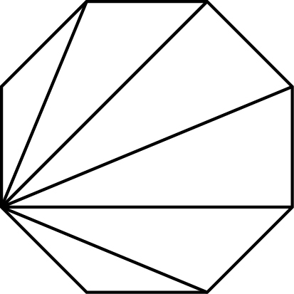

There are 6 triangles.

(b) 6 × 180° = 1080°  
The angle sum of an octagon is 1080°.

Question 17 6 marks [8.3]

(a) [6, -4] means slide 6 units to the right and 4 units down.

(b)

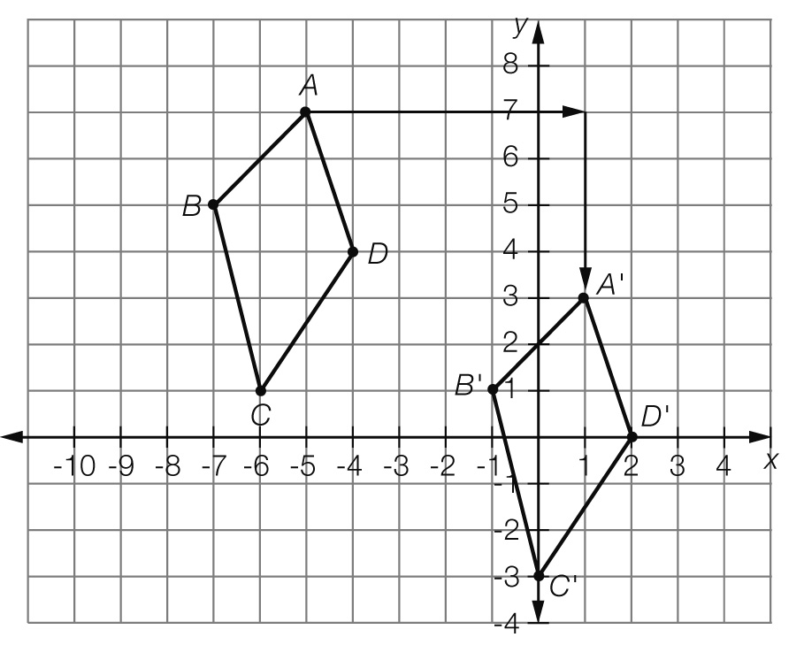

(c) *A*' (1, 3), *B*' (-1, 1), *C*' (0, -3), *D*' (2, 0)

Question 18 6 marks [8.3]

(a)

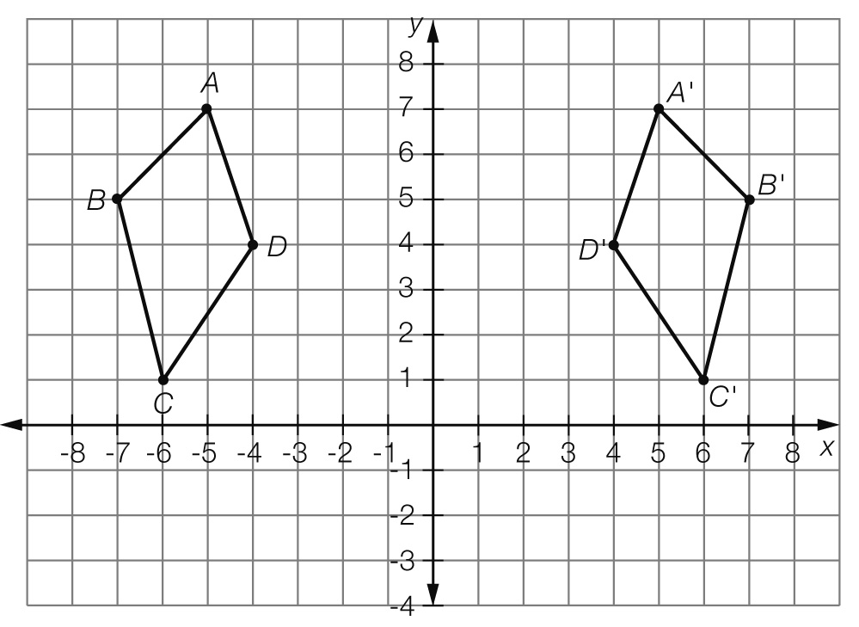

(b) *A*' (5, 7), *B*' (7, 5), *C*' (6, 1), *D*' (4, 4)

Question 19 2 marks [8.5]

∆*PQR* ≡ ∆*RSP* ≡ ∆*QPS* ≡ ∆*SRQ*

∆*PTQ* ≡ ∆*RTS*

∆*RTQ* ≡ ∆*PTS*

Question 20 2 marks [8.5]

*x* = 5 m

*y* = 167°

Question 21 2 marks [8.4]

Left and right triangles are congruent and are isosceles triangles.

Top and bottom triangles are congruent and are isosceles triangles.

*x* = 63° (base angles of an isosceles triangle)

Short answer total marks: 40

Extended answer section

Question 22 4 marks [8.2]

(a) 4*x* + 14° + 2*x* + 10° + 3*x* + 3° = 180° (angle sum of a triangle)

9*x* + 27° = 180°  
9*x* = 153°  
*x* = 17°

(b) 4*x* + 14° = 4 × 17° + 14° = 82°  
2*x* + 10° = 2 × 17° + 10° = 44°  
3*x* + 3° = 3 × 17° + 3° = 54°

Extended answer total marks: 4

TOTAL test marks: 52